Array Assignment   
**package** ArrayAssignment;

// Write a Java program to sum values of an array.

**public** **class** Sumarray {

**public** **static** **void** main(String[] args) {

**int** arr[]= {10,50,30,60,2,9};

**int** sum = 0;

**for**(**int** i=0;i<arr.length;i++)

{

sum = sum + arr[i];

}

System.***out***.println("Total sum is >>"+sum);

}

}

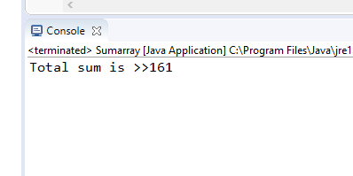  
  
**package** ArrayAssignment;

//Write a Java program to calculate the average value of array elements

**public** **class** Averagearray {

**public** **static** **void** main(String[] args) {

**int** arr[] = { 10, 50, 60, 30, 40, 50, 60 };

**int** sum = 0;

**int** avg = 0;

**int** len = arr.length;

**for** (**int** i = 0; i < arr.length; i++) {

sum = sum + arr[i];

}

avg = sum / len;

System.***out***.println("Average of array num is >>" + avg);

}

}

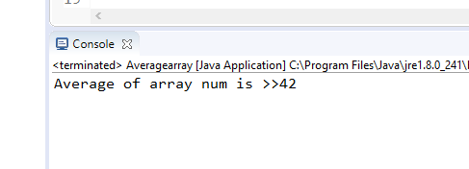  
  
**package** ArrayAssignment;

//Write a Java program to test if an array contains a specific value

**public** **class** arraysearch {

**public** **static** **void** main(String[] args) {

**int** intarr [] = {10,20,30,40,50,60};

**int** i;

**for**( i=0;i<intarr.length;i++)

{

**if**(intarr[i]==50)

{

System.***out***.println("20 is at the position of>>"+i );

**break**;

}

}

**if**(i == intarr.length)

{

System.***out***.println("number not found");

}

}

}

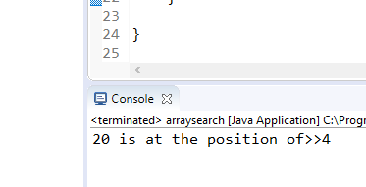  
  
**package** ArrayAssignment;

//Write a Java program to find the index of an array element

**public** **class** Indexarray {

**public** **static** **void** main(String[] args) {

**int** intarr [] = {10,20,30,40,50,60};

**int** i;

**for**( i=0;i<intarr.length;i++)

{

{

System.***out***.println(+intarr[i]+" is at position of >> "+i );

}

}

}

}

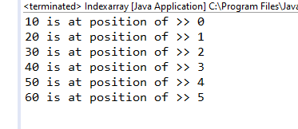  
**package** ArrayAssignment;

//Write a Java program to copy an array by iterating the array

**import** java.util.Arrays;

**public** **class** Copyarray {

**public** **static** **void** main(String[] args) {

**int**[] my_array = {25, 14, 56, 15, 36, 56, 77, 18, 29, 49};

**int**[] new_array = **new** **int**[10];

System.***out***.println("OLD ARRAY ");

**for**(**int** x: my_array )

{

System.***out***.print(+x+" ");

}

// System.out.println("Source Array : "+Arrays.toString(my_array));

**for**(**int** i=0; i < my_array.length; i++) {

new_array[i] = my_array[i];

}

System.***out***.println();

System.***out***.println("NEW ARRAY ");

**for**(**int** y : new_array)

{

System.***out***.print(+y+" ");

}

// System.out.println("New Array: "+Arrays.toString(new_array));

}

}

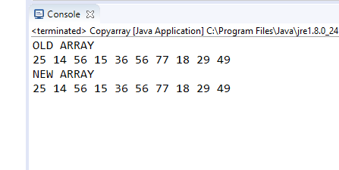  
  
**package** ArrayAssignment;

**import** java.util.Arrays;

//Write a Java program to find the maximum and minimum value of an array

**public** **class** Maxminarray {

**public** **static** **void** main(String[] args) {

**int** intarr [] = {10,20,50,60,5,70,30,40};

Arrays.*sort*(intarr);

**int** max = intarr.length-1;

**int** maxx = intarr[max];

**int** min = intarr[0];

System.***out***.println("maximum number of array>> "+maxx);

System.***out***.println("minimum number of array>> "+min);

}

}

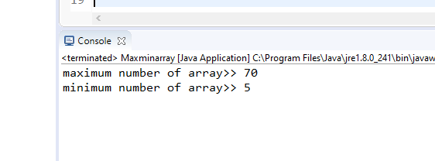  
  
**package** ArrayAssignment;

//Write a Java program to reverse an array of integer values.'

**import** java.util.Arrays;

**public** **class** Reversearray {

**public** **static** **void** main(String[] args) {

**int** intarr [] = {10,20,50,60,5,70,30,40};

**for**(**int** i=intarr.length-1;i>=0;i--)

{

System.***out***.print(intarr[i]+" ");

}

}

}

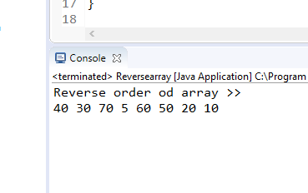  
  
**package** ArrayAssignment;

**import** java.util.Arrays;

//Write a Java program to test the equality of two arrays

**public** **class** Equalityarray {

**public** **static** **void** main(String[] args) {

**int** arr[] = {10,20,30,40,50};

**int** arr2[] = {10,20,30,40,50};

**boolean** flag = Arrays.*equals*(arr,arr2);

**if**(flag)

System.***out***.println("<<Arrays are equal>>");

**else**

System.***out***.println("<<Arrays are not equal>>");

}

}

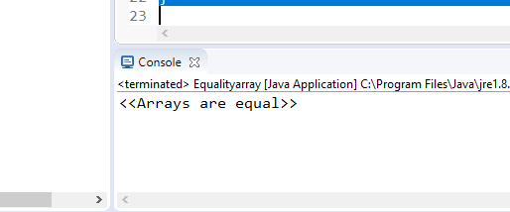  
  
**package** ArrayAssignment;

//Write a Java program to find the number of even and odd integers in a given array of integers.

**import** java.util.Arrays;

**public** **class** Evenoddarray {

**public** **static** **void** main(String[] args) {

**int** arr[] = {10,5,23,26,98,76,42,45,88,66};

System.***out***.println("EVEN NUMBERS");

**for**(**int** i=0;i<arr.length;i++)

{

**if**(arr[i]%2==0)

{

System.***out***.print(arr[i]+",");

}

}

System.***out***.println();

System.***out***.println("ODD NUMBERS");

**for**(**int** i=0;i<arr.length;i++)

{

**if**(arr[i]%2!=0)

{

System.***out***.print(arr[i]+",");

}

}

}

}

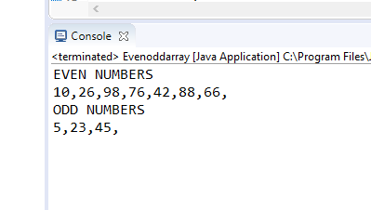  
  
**package** ArrayAssignment;

**public** **class** LinearBinarySearch {

**public** **static** **void** main(String[] args) {

**int** y[]= {11 ,22 ,33,44,55,66,77,88};

System.***out***.println("LINEAR SEARCH");//Linear Search

**int** i;

**for**( i=0;i<y.length;i++)

{

**if**(y[i]==33)

{

System.***out***.println("Record Found 33 is at the position of>>"+i );

**break**;

}

}

**if**(i == y.length)

{

System.***out***.println("number not found");

}

System.***out***.println("BINARY SEARCH");//Binary Search

**int** s=33;

**int** f=0;

**int** l= y.length-1;

**while**(f<=l)

{

**int** mid=(f+l)/2;

**if**(y[mid]==s)

{

System.***out***.println("record found");

**break**;

}

**else** **if**(y[mid]<s)

f=mid+1;

**else**

l= mid-1;

}

**if**(f>l)

System.***out***.println(" no record found");

}

}

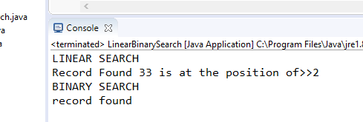  
**package** ArrayAssignment;

**import** java.util.Scanner;

/* Take 20 integer inputs from user and print the following:

number of positive numbers

number of negative numbers

number of odd numbers

number of even numbers

number of 0s.*/

**public** **class** MenuDrivenArray {

**public** **static** **void** main(String[] args) {

**int**[] arr = **new** **int**[10];

Scanner sc = **new** Scanner(System.***in***);

System.***out***.println("Enter the element of array>> ");

**for** (**int** i = 0; i < arr.length; i++) {

arr[i] = sc.nextInt();

}

System.***out***.println("enter 1. positive 2. negative 3. odd 4. even 5. zero");

**int** input = sc.nextInt();

**int** positive;

**int** negative;

**int** odd;

**int** even;

**int** zero;

**switch** (input) {

**case** 1:

System.***out***.println("Positive numbers");

**for** (**int** i = 0; i < arr.length; i++) {

**if** (arr[i] > 0) {

System.***out***.print(arr[i] + " ");

}

}

**break**;

**case** 2:

System.***out***.println("Negative numbers");

**for** (**int** i = 0; i < arr.length; i++) {

**if** (arr[i] < 0) {

System.***out***.print(arr[i] + " ");

}

}

**break**;

**case** 3:

System.***out***.println("Odd numbers");

**for** (**int** i = 0; i < arr.length; i++) {

**if** (arr[i] % 2 != 0) {

System.***out***.print(arr[i] + " ");

}

}

**break**;

**case** 4:

System.***out***.println("even numbers");

**for** (**int** i = 0; i < arr.length; i++) {

**if** (arr[i] % 2 == 0) {

System.***out***.print(arr[i] + " ");

}

}

**break**;

**case** 5:

System.***out***.println("zero numbers");

**for** (**int** i = 0; i < arr.length; i++) {

**if** (arr[i] % 10 == 0) {

System.***out***.print(arr[i] + " ");

}

}

**break**;

**default**:

System.***out***.println("<<<<Invalid input>>>>");

}

}

}

